Image Compression Using Modified Block Truncation Coding Algorithm
Chung-Woei Chao, Chaur-Heh Hsieh, Po-Ching Lu
Signal Processing: Image Communication, Vol. 12, No. 1, pp. 1-11, March 1998
Abstract
This paper presents a modified block truncation coding(BTC) algorithm for image compression. Similar blocks in an image are merged into a cluster and represented with the cluster center.
- Introduction
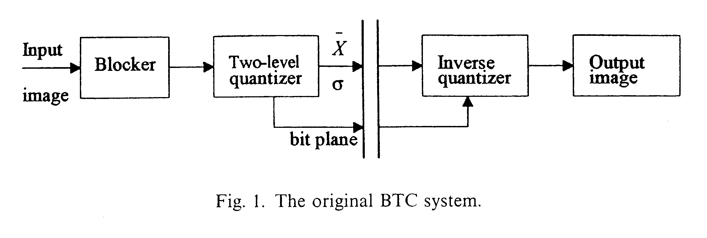
- The Proposed Algorithm
The proposed algorithm mainly consists of three processes: block clustering, search-order coding and vision BTC.

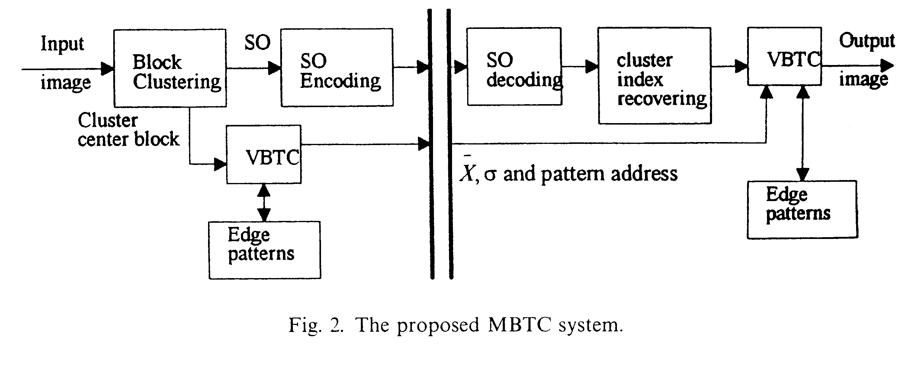

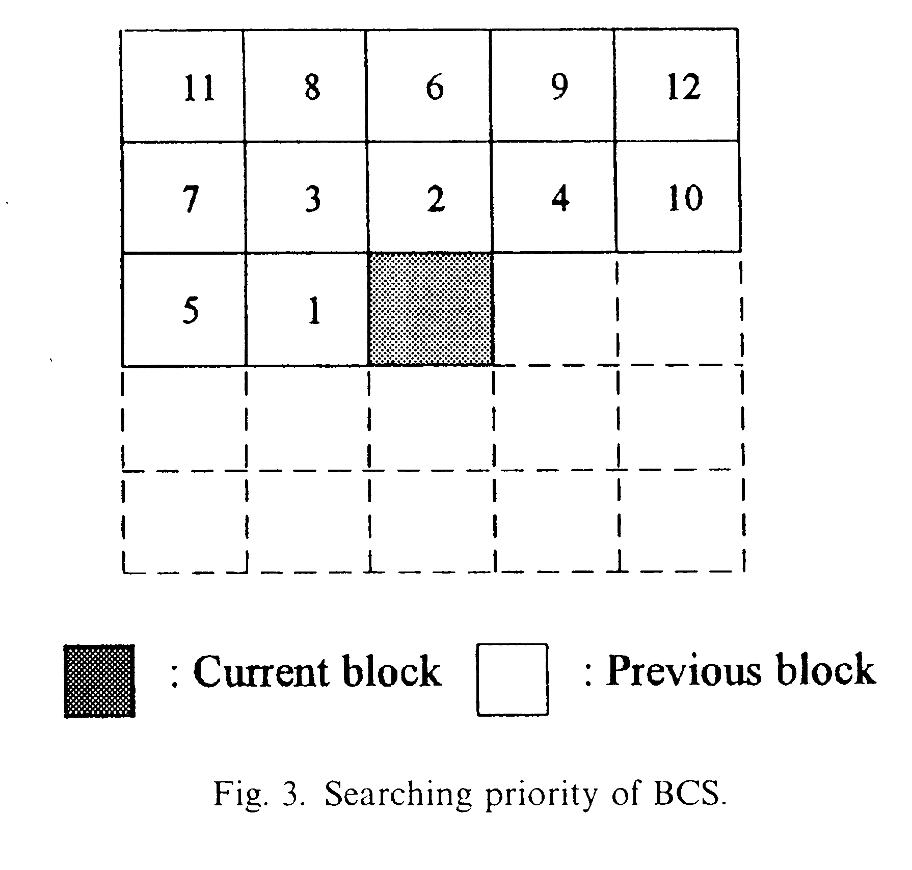
- Experimental Results

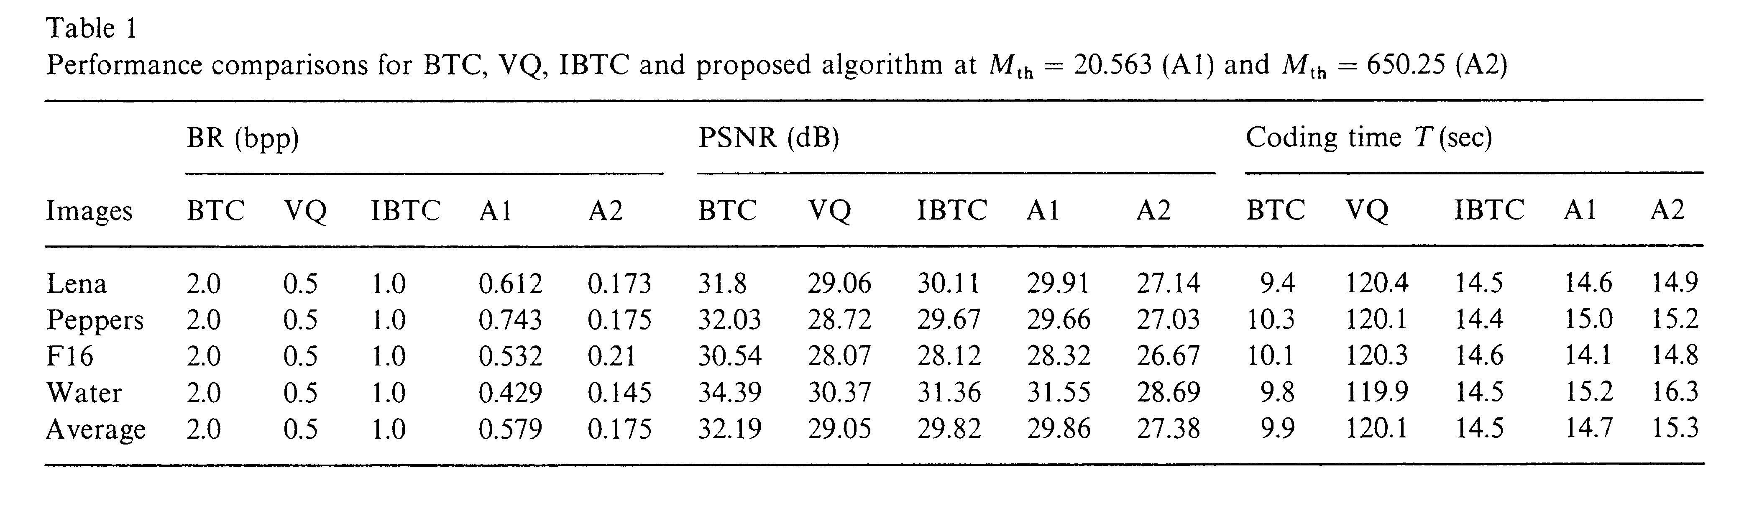
- Conclusion
The compression ratio of the proposed algorithm is much higher than that of the original BTC with similar quality. The compression performance achieved is comparable to or superior to the VQ with much less amount of computation.
Created by : Chia-Hao Yang
Date : August 7, 1998

